NATIONAL UNIVERSITY OF MODERN LANGUAGE ISLAMABAD
Lab 10


Submitted to:
Sir Hassan Shah
Submitted by:
Zulqarnain Hassan
Roll No: …………………… SP21379
Subject: …………………… computer network
Department: ……………… BSSE-5-Afternoon
Date: ……………………… 13-12-2024

Objectives
- Configure the Router for static routing.

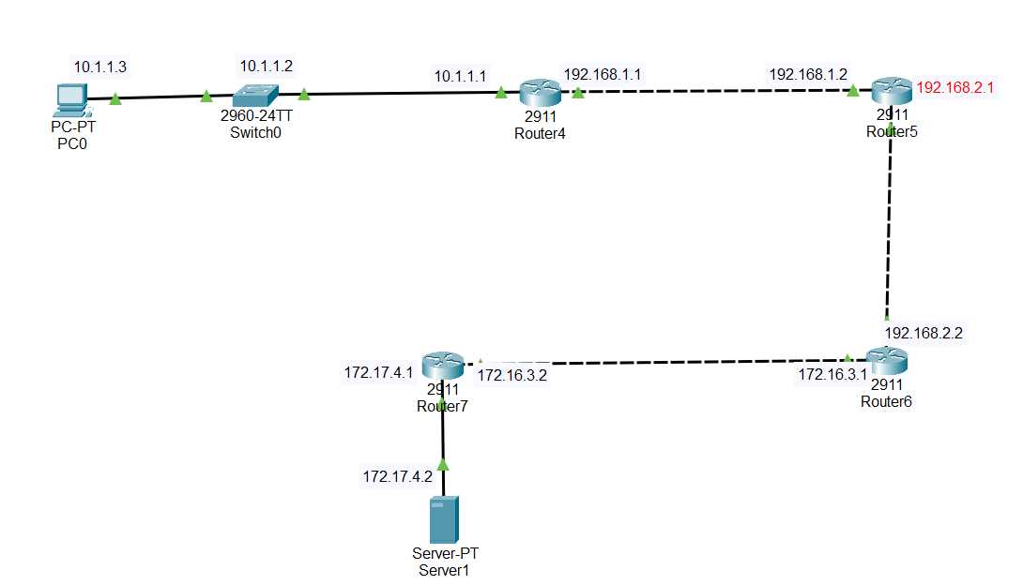
Task 1
Router4:
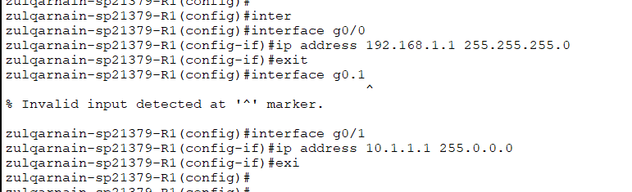

Router5:

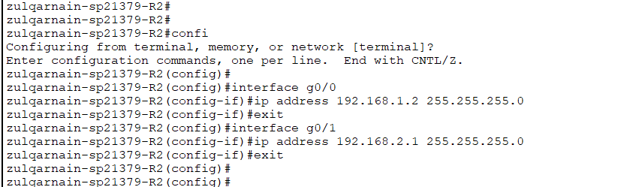

Router6:
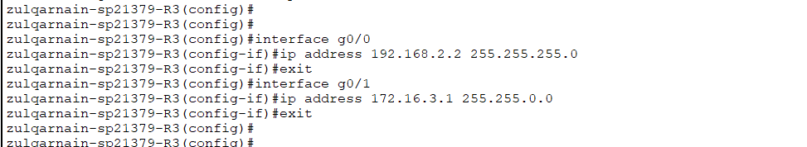

Router7:
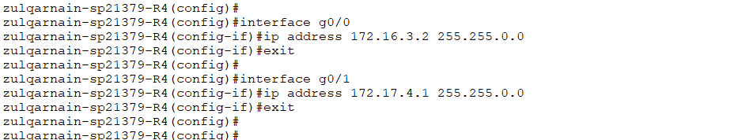

Task 02
Router4:
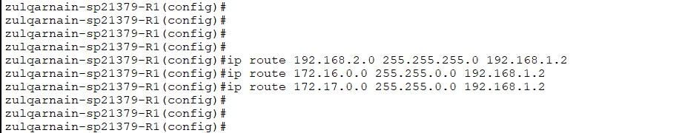

Router5:

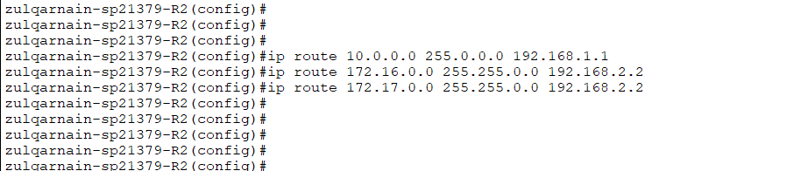
Router6:

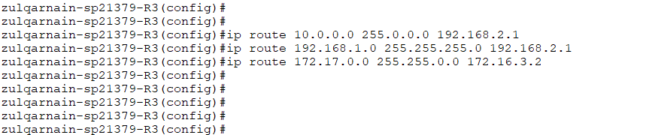

Router7:

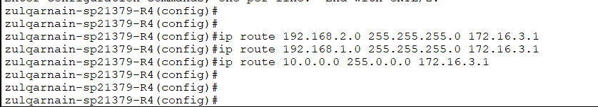

Task 3
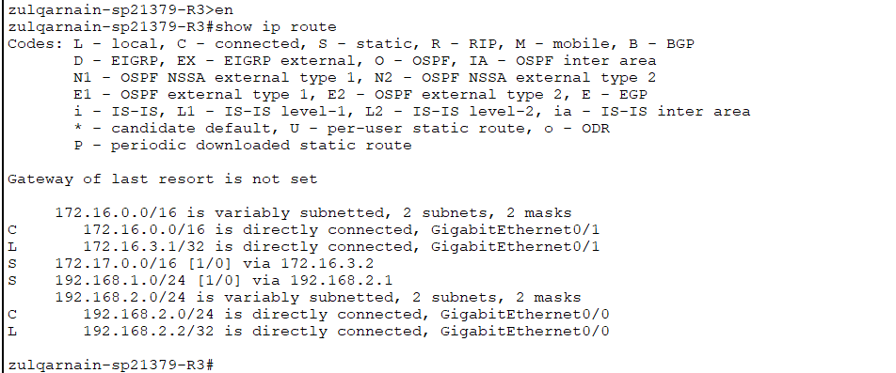

Ping index.html from Pc0
